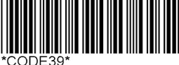
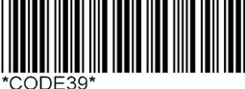

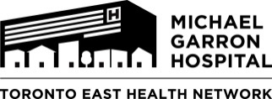

Rapid Access Addiction Medicine (RAAM) Clinic-
Referral Form

Patient Label

The MGH RAAM clinic is staffed by an interdisciplinary team of a physician and counsellor. It provides short term outpatient addiction-related medication and counseling treatment.

To ensure continuity of care, please fax this referral for all patients to 416-461-1164.

Please instruct patients to go to the Admitting Department, First Floor, MGH between 8:45-11 am Tuesday and Fridays. Please give a copy of this form to the patient to bring with them.

Patient Last Name: | Patient Given Name: | DOB: (Day/ Month/ Year)
Address: | Town/ City: Prov: | Postal Code:
OHIP: | Version Code: | Telephone #:
Date of Referral: | Referred By: | Family Physician:

Short description of addiction issue(s):

Past Medical History:

Medication list:

***Though we try our best to reduce wait times at clinic, please inform patients that they may have to wait to see a physician****

SP-936 (Rev.2018) Forms WG Approval Date 03/2018

